### PROJECTS

### Topic: Data presentation in dashboard

Based on the .csv/ .xlsx file provided, we are going to analyze and develop a dashboard to understand the customer data of a UK bank. Use filters, parameters and actions

Wherever possible to make the dashboard interactive.

1. **Create a motion chart to compare the sales and profit through the years.**

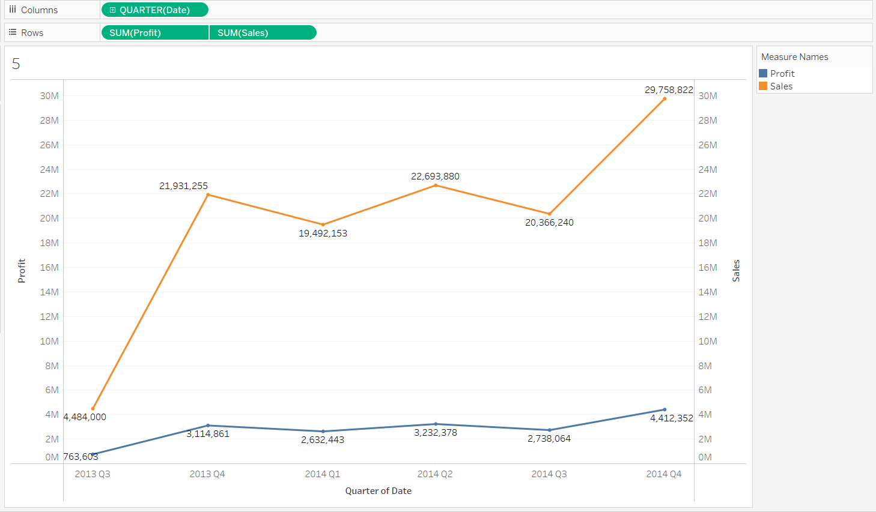

1. **Use customized shapes to visualize product related data in a scatter plot chart.**

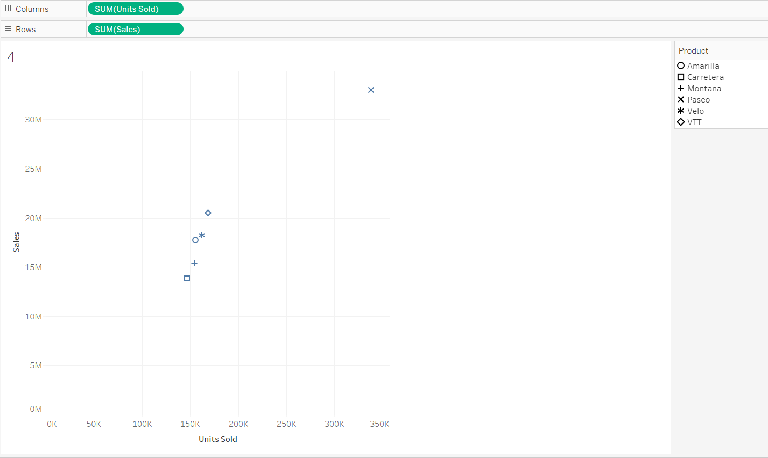

1. **Create a stacked bar chart to view the gender wise average age in every region.**

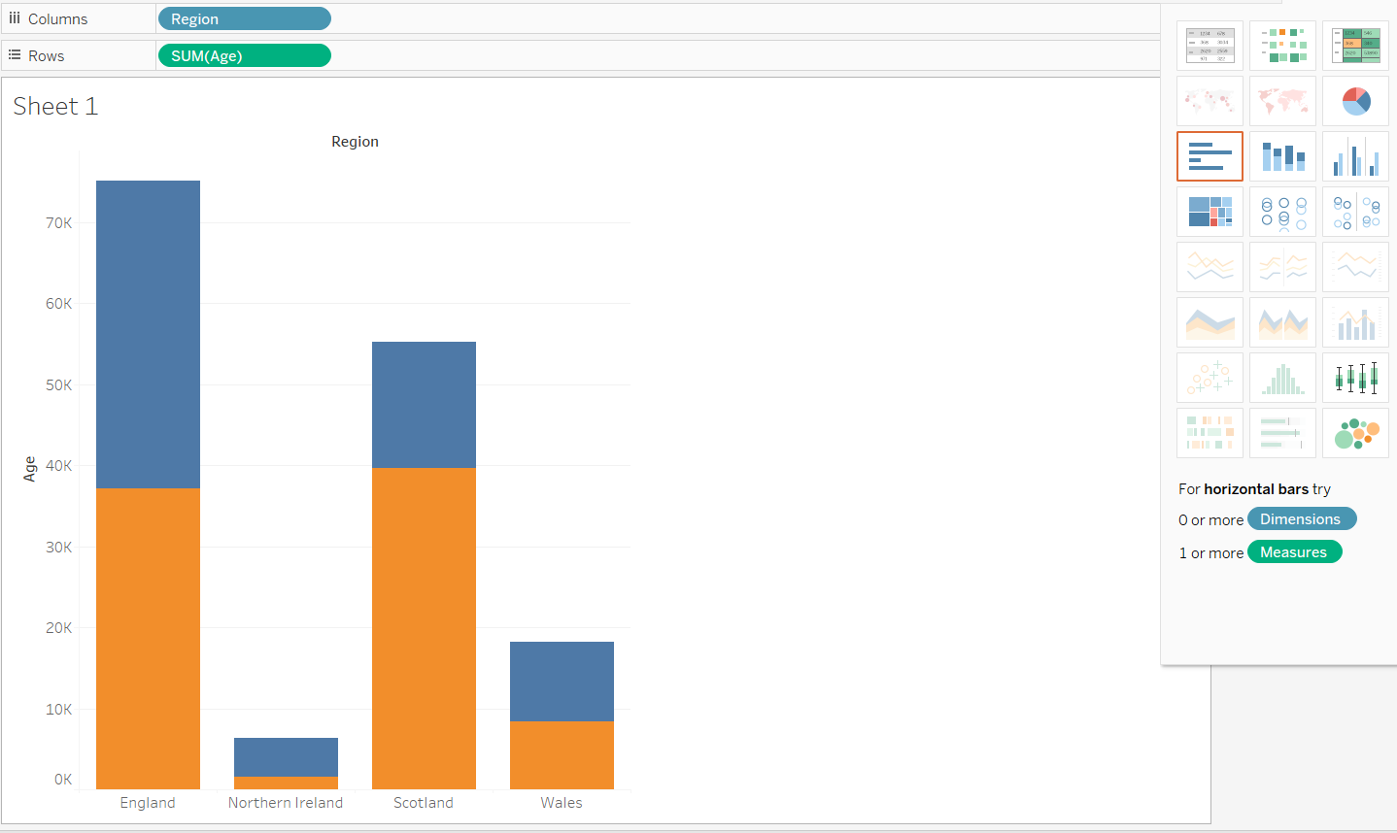

1. **Create a pie chart which displays a percent of total balances in a region wise manner.**

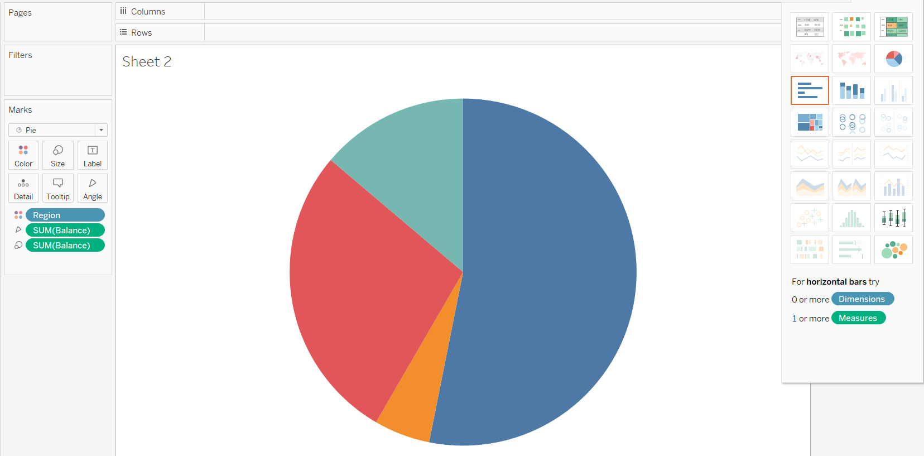

1. **Compare the region wise average balance with the (region wise average balance)**

**in-terms of its job classifications.**

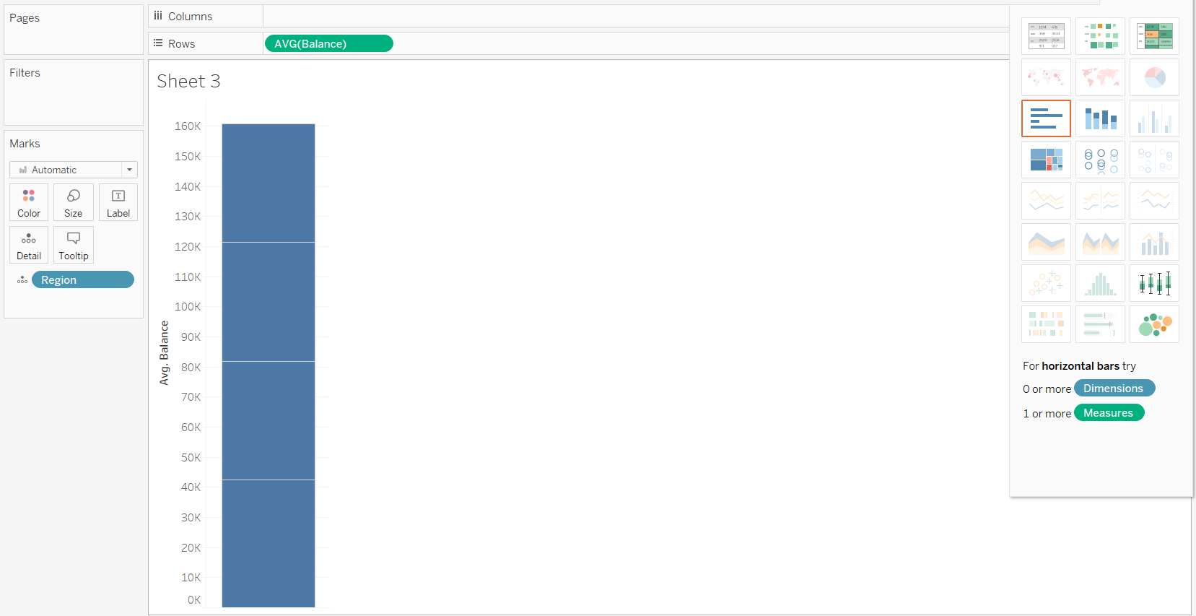

1. **Region wise pie chart displaying the job classifications with respect to its balances.**

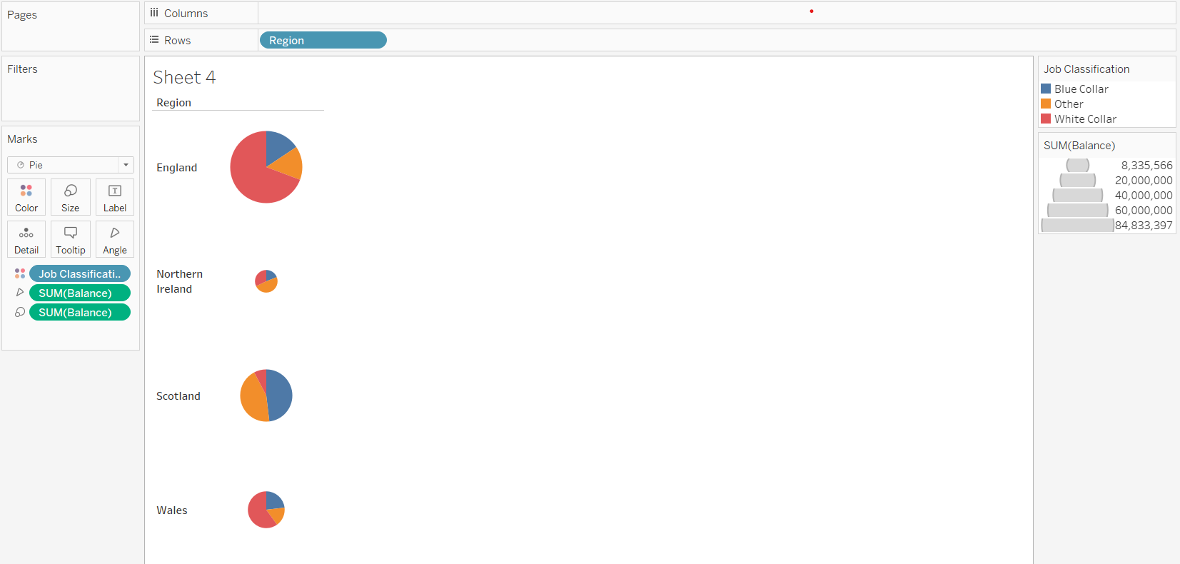

1. **Create a donut pie chart which displays a percent of total balances in a regionwise manner.**

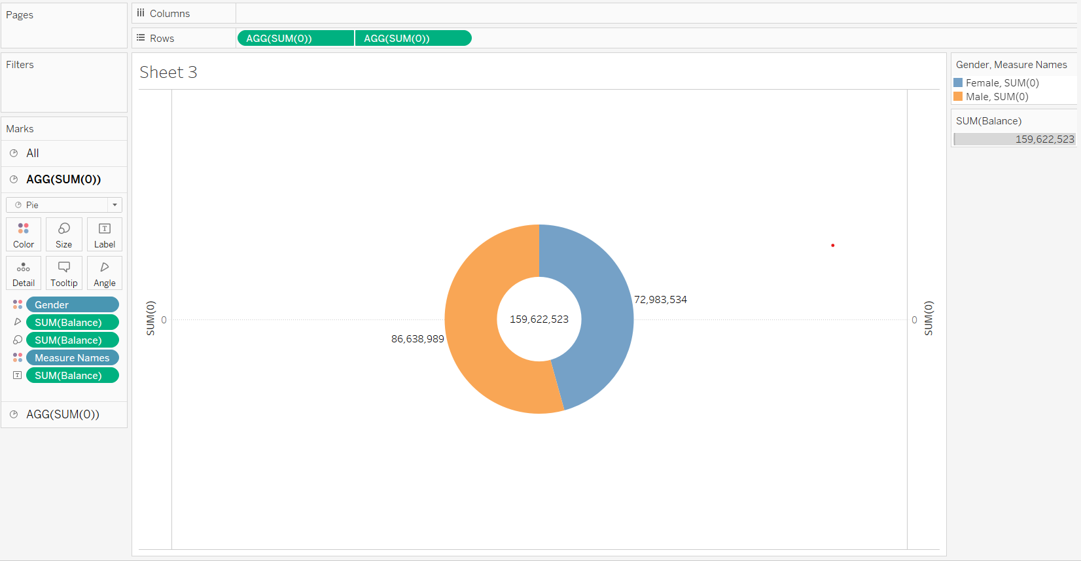

**8) Create a map to analyze the gross sales around the given countries.**

